**Q1. Data mismatch exception code ?**

**Code:**

#try except with type define exception

a=1

b=2

c=0

try:

c=a/b

print(c)

#put charter not number on console

n=int(input("enter the number :"))

#note this can only handle arithematic error

except ZeroDivisionError as e :

print("we can't do it :",e)

#this will handle number format exception

except ValueError as e :

print("we can't do it :",e)

finally:

# here you write that stuff for example to disconnect the database conectivity etc

print("hello")

print(c)

**output:**

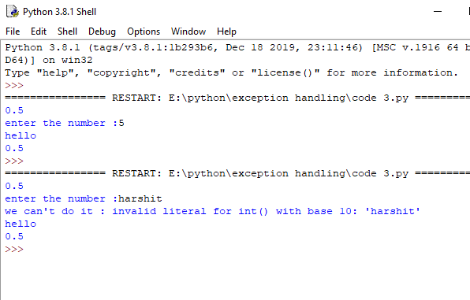

**Q2 module import exception ?**

**Code:**

import sys

a = [1, 2, 3]

try:

print( "Second element = %d" %(a[1]))

# Throws error since there are only 3 elements in array

print( "Fourth element = %d" %(a[3]))

except:

print( "An error occurred")

print("Oops!",sys.exc_info()[0],"occured.")

**output :**

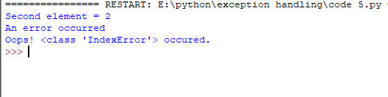

**Code 2:**

import random

try:

print(os.getcwd())

except Exception as e :

print("exception :",e)

**output :**

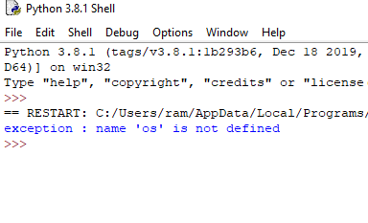

**Q2.** 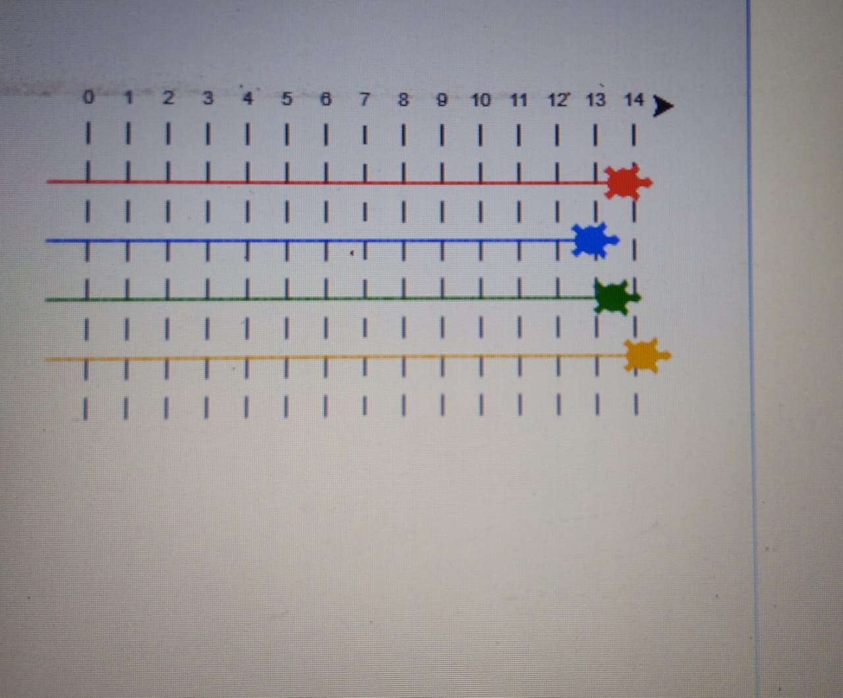

Today's Task: Turtle racing game

Step 1 : draw a racing track

Step 2: create four turtle object of different color

Step 3: move the turtles to their starting positions

Step 4: send them moving across the screen( by using randint() function inside forward ())

Step 5: display the color of the turtle who won the race on screen.

(By using write() function). Kindly do not copy the code from internet just try to make your own.

**Code :**

import turtle

import random

import time

#screen

screen=turtle.Screen()

harshit=turtle.Turtle()

#title

screen.title("Turtle game ")

screen.bgcolor("lightgreen")

harshit.color("white")

harshit.speed(0)

harshit.penup()

#t1.setpos(-x,y)

harshit.setpos(-100,200)

# text on window

harshit.write("Turtle Game ",font =("arial",30,"bold"))

harshit.penup()

k=5

for i in range(1,11):

harshit.setpos(-230+k,150)

harshit.write(i,font =("arial",10,"bold"))

k=k+40

dot_distance=25

width=16

heigth=11

harshit.setpos(-220,130)

harshit.penup()

for y in range(heigth):

for i in range(width):

harshit.speed(0.1)

harshit.dot()

harshit.forward(dot_distance)

harshit.backward(dot_distance*width)

harshit.right(90)

harshit.forward(dot_distance)

harshit.left(90)

**output:**

